Advanced Discounts - Design Notes

Subject

Document History

|  |  |  |  |  |
| --- | --- | --- | --- | --- |
| **Version** | **Status** | **Author** | **Description** | **Date** |
| 0.1 | Started | M Higginson | Initial Version | 17/02/2009 |
| 0.9 | Issued | M Higginson | Reviewed by CS | 24/02/2009 |
| 1.0 | Released | M Higginson | Added time estimates | 25/02/2009 |
| 1.1 | Abandoned | M Higginson | Rewrote for SRS 0.8 changes | 02/03/2009 |
| 2.0 | Released | M Higginson | Rewrote to use line discount fields + misc non-SRS changes (post 0.9 SRS) | 12/03/2009 |
| 2.1 | Update | M Higginson | Added sections 6.5 Letters, 7.8 Plugins.and 7.9 OLE Drill-Down. Extended section 6.2 Customisation. | 25/03/2009 |
| 2.2 | Released | M Higginson | Redefined Multi-Buy BOGOF definition | 26/03/2009 |
| 2.3 | Update | M Higginson | Updated based on reality:-   * Corrected User Permissions Checks * Updated TTD section | 09/04/2009 |
| 2.4 | Update | M Higginson | Updated after completion of VBD:-   * Corrected section numbering in 4.2 * Modified Edition section of 4.1.1 | 30/04/2009 |

Distribution List

|  |
| --- |
| **Name** |
|  |
|  |
|  |
|  |
|  |

# 1.0 Overview

## Work Items

|  |  |
| --- | --- |
| **Generic Base Changes** | **38.75 days** |
| New System Setup Fields (5.2) | 0.5d |
| New Transaction Line Fields (5.1)  Add New Fields (0.25d), Apply system wide (5.1.1) (38d) | 38.25d |

|  |  |
| --- | --- |
| **Multi-Buy Discounts (2.0) (requires Generic Base)** | **20.75 days** |
| New Misc\MultiBuy.Dat File (5.3)  Record Structure/File Definition (0.25d), Open/Close (0.125d), Update Btrieve Files.Doc and TechDocs.Doc (0.125) | 0.5d |
| MultiBuys Tab  Customer/Supplier Tabs (0.5d), Stock Tab (0.5d), Common Frame (3d), Add (1d), Edit (0.25d), Delete (0.25d), Copy (0.5d), Check (0.5d), Stock Specific features(0.5d), Custom Button Repair (0.25d) | 7.25d |
| MBD Calculation / Maintenance Class  Class Setup (0.25d), MBD Lookup/Storage (1d), Line Totals (0.25d), Discount Calculation (1d), Quantity Management (0.5d), Update Lines (0.5d), Add MBD Desc Line (0.25d), Delete MBD Desc Line (0.25d) | 4d |
| Transaction Line Multi-Buy Discount Support (2.1.1/2.2.6)  Research (0.25d), UI Changes (1.5d), MBD Management (2d), Validation (0.5d), | 4.25d |
| Telesales Multi-Buy Discount Support (2.1.2/2.2.7)  Research (0.25d), Stock Processing (0.5d), Dialog (1.5d), Apply discounts (0.75d) | 3d |
| Object Price Lookup (2.1.3/2.2.4) | 0.5d |
| Object Stock Enquiry (2.1.4/2.2.5) | 1d |
| Transaction Header Discount Column (2.2.8) | 0.25d |

|  |  |
| --- | --- |
| **Total Transaction Discount (3.0) (requires Generic Base Changes)** | **7.5 days** |
| Code Research into Transaction Save Process and Telesales Process | 1d |
| Apply TTD Button / Menu Option  Transaction Window (SaleTx2U.Pas) (3.1.1), Telesales (CuStkL1U.Pas) (3.1.2) | 1d |
| TTD Calculation / Maintenance Class  Class Setup (0.25d), Line Analysis (0.5d), Line Totals (0.25d), Transaction Totals (0.5d), Update Trans Lines (1d), Delete TTD Desc Line (0.25d), Discount Calculation (1d) | 3.75d |
| Total Transaction Discount Dialog  Basic Window Setup (0.5d), TTD Totals (0.25d), VBD Offer (0.25d), Validation (0.5d), Update Lines (0.25d) | 1.75d |

|  |  |
| --- | --- |
| **Value Based Discounts (4.0) (requires Generic Base and Discount Record Changes)** | **7.5 days** |
| Code Research into Discounts List/Dialog | 0.5d |
| Value Based Discount Record Support (4.2)  4.3.1 Customer/Supplier Discounts List Mods (0.75d), 4.3.2/4.4 Discount Record Mods (1d), Precautionary Checks (4.4) (1d) | 2.75d |
| VBD Calculation / Maintenance Class  Class Setup (0.25d), Line Analysis (0.25d), Line Totals (0.125d), Add VBD Desc Line (0.5d), Delete VBD Desc Line (0.125d), Update Trans Lines (0.5d), Discount Calculation (0.5d)  NOTE: Assumes significant re-use of work from TTD Calculation Maintenance Class | 2.25d |
| Transaction VBD Support (4.1.1) | 1d |
| Telesales VBD Support (4.1.2) | 1d |

|  |  |
| --- | --- |
| **Other Work** | **31.25 days** |
| Exchequer Back-To-Back Process (6.1)  Research (0.5d), Remove SOR Discounts (0.25d), Apply MBD/TTD/VBD (1.5d) | 2.25d |
| Customisation Changes (6.2) (MH) | 0.5d |
| SQL Edition (6.3)  Transaction Line Schema (CS 0.25d), MultiBuy Schema (CS 0.25d), Conversion Process (CS/MH/JW 1d), Update Data Import Files (CS 0.25d) | 1.75d |
| Installer (6.4) (MH)  Add MultiBuy.Dat to existing companies (MH 0.25d) | 0.25d |
| Toolkits (7.1/7.2) (PR) (Requires Generic/2.0/3.0/4.0)  Toolkit DLL – New TL Fields (0.5d), New System Setup Fields (0.25d), Disc Matrix Funcs (0.5d), MultiBuy funcs (1d)  COM Toolkit - New TL Fields (0.25h), New Setup Fields (0.5d), Cust/Supp Discounts Object (0.25d), Customer/Supplier/Stock Multi-Buys Object (1.5d), ITransactionLine.tlMultiBuys (0.5d), ITransactionLine.Save MBD Mods(0.5d), ITransaction.ApplyTTD (0.5d), ITransaction.Save VBD Mods (0.5d) | 6.75d |
| Form Designer – New Fields (7.3) (Requires Generic) (MH/PR) | 0.5d |
| eBusiness (7.4)  Import Multi-Buy Support (1.25d), Import VBD Support (0.75d), Transaction Window TTD Support (1d), COM Pricing/eBusiness Export (3d)  NOTE: Should be able to re-use a lot of the Exchequer code | 6d |
| Trade Counter (7.7) (Requires Toolkits) (NF/BH was discussed?)  Transaction Total Discounts (3d), Value Based Discounts (3d), Multi-Buy Discounts (5d)  NOTE: Guessed as ~50% of Exchequer time in lieu of better idea | 11d |
| Importer (7.5) (Requires Toolkits) (BH)  New Transaction Line fields (0.5d), VBD Records (0.25d), MBD Records (1d) | 1.75d |
| ODBC DDF’s (7.6) (NF) | 0.5d |

|  |  |
| --- | --- |
| **Total – all sections coded sequentially by a single person** | **105.75d** |

# 2.0 Multi-Buy Discounts

Multi-Buy Discounts are pre-specified stock discounts based on the quantity purchased/sold, they can be defined against Stock items or against Customers/Suppliers for a specified Stock item.

Supported discounts can be specified in the following formats:-

Buy X Get Y Free, e.g. Buy 3 Get 1 Free – customer pays for 3 and gets a 4th free

Buy X For Value, e.g. Buy 3 For £1.00

Buy X Get Y% Off, e.g. Buy 3 get 25% Off

Note 1: For Packs the Multi-Buy Discount is assumed to be against the pack, not the individual units of the pack.

## 2.1 Trigger Conditions

MBD only applies to SPOP versions of Exchequer, there is no System Setup switch to enable them as the definition of a MBD against Customer/Supplier/Stock causes it to be used where applicable.

MBD only applies to xQU / xOR / xIN / xJI / SRI / PPI, their auto equivalents and Telesales.

### 2.1.1 Transactions

Multi-Buy Discounts will be automatically checked for and offered on the transaction line when adding a new transaction line and the Multi-Buy Discount field will be read-only.

When editing an existing transaction line Multi-Buy Discounts will not be offered, but the Multi-Buy Discount field will be read-write allowing the user to modify the discount as required.

### 2.1.2 Telesales

The MBD will be implemented within the Finish button – Generate Order process and will display a dialog (see 2.3.7) containing the MBD’s for all lines being sold, those OK’d by the user will be applied to the resulting transaction.

NOTE: This should execute before the TTD/VBD code has executed.

### 2.1.3 Object Price Lookup

The Object Price Lookup dialog will automatically show Multi-Buy Discount information for SPOP versions of Exchequer where Multi-Buy Discounts have been defined.

### 2.1.4 Object Stock Enquiry

The Object Stock Enquiry dialog will automatically show Multi-Buy Discount information for SPOP versions of Exchequer where Multi-Buy Discounts have been defined.

## 2.2 Implementation

### 2.2.1 Customer/Supplier Multi-Buys Tab

For SPOP versions a new ‘Multi-Buys’ tab will be added onto the Customer/Supplier Record between the Discounts and Ledger Tabs, it will have the following columns:-

|  |  |
| --- | --- |
| Stock Code |  |
| Buy Quantity | mbdBuyQuantity |
| Free Quantity | for mbtGetFree discounts set to mbdRewardValue else blank |
| Purchase Value | for mbtForAmount discounts set to mbdRewardValue else blank |
| Discount% | for mbtGetPercentOff discounts set to mbdRewardValue else blank |
| Start Date | blank if not using date range |
| End Date | blank if not using date range |

The following buttons/menu options will be available:-

|  |  |
| --- | --- |
| Add | Adds a new Multi-Buy Discount |
| Edit | Edits the selected Multi-Buy Discount |
| Delete | As per the normal Discounts tab this pops up a menu offering two options:-  Delete this Discount – Deletes the selected Multi-Buy Discount  Block Delete Discounts – Displays a Block Delete Discount dialog with various options – see standard Discounts tab. |
| Copy | As per the normal Discounts tab this pops up a menu offering two options:-  From another account – Displays a dialog requesting an account code and copies the Mutli-Buy Discounts in from that account after removing any pre-existing discounts.  To same type accounts – Copies the Multi-Buy Discounts for the current account out to all other accounts after removing any pre-existing discounts. |
| Check | As per the normal Discounts tab this runs through the multi-buy discounts and warns if any will result in a below cost selling price. |

NOTE: Don’t forget to check that the Custom Buttons/Menu Options on the Ledger Tab still work.

Technical Note: It is suggested that the Multi-Buys List and associated functionality be implemented in a separate frame that can be re-used on the Stock Multi-Buys Tab (2.2.2).

### 2.2.2 Stock Multi-Buys Tab

For SPOP versions a new ‘Multi-Buys’ tab will be added onto the Customer/Supplier Record between the Qty Breaks and Ledger Tabs, it will function in a similar manner to the Customer/Supplier Multi-Buy Discounts Tab (2.2.1) except for the following:-

1. No Stock Code column in the list
2. The Copy button has no menu and asks for a Stock Code to copy the discounts from.
3. To be consistent with the other Stock Record Tabs add two custom buttons/menu options.

NOTE: Don’t forget to check that the Custom Buttons/Menu Options on the other tabs still work using their correct Handler Id’s and Text Id’s.

### 2.2.3 Multi-Buys Discount Record

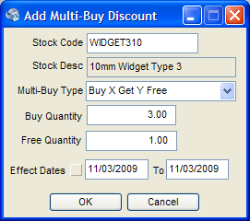 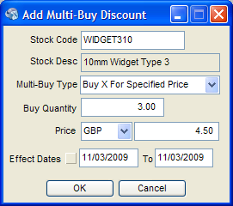 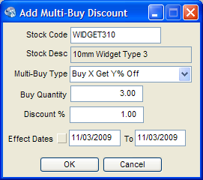

The Multi-Buys Discount Record dialog will need to be dynamically reset the Free Quantity/Price/Discount % section as the Multi-Buy Type is specified.

When saving a Multi-Buy Discount the validation must ensure that no other MBD’s of a different type clash within the same date-range (if used) or currency (Buy X for Amount type only).

### 2.2.4 Object Price Lookup

The ObjectPrice Lookup window will be modified to append Multi-Buy Discounts to the end of the existing textual pricing information.

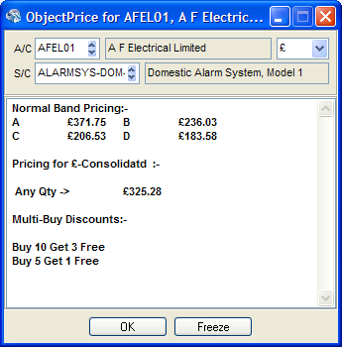

### 2.2.5 Object Stock Enquiry

The ObjectStock Enquiry dialog will be modified to list available Multi-Buy Discounts underneath the stock item within the tree:-

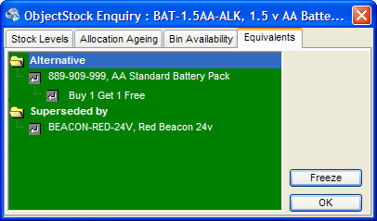

**MR Action:- Will need a graphic for the tree to represent ‘Multi-Buy Discount’**

### 2.2.6 Transaction Line Dialog

Several changes are being made to the Transaction Line dialog to support Advanced Discounts:-

* When adding transactions a Multi-Buy Discount Availability (MBDA) section will be shown at the bottom if Multi-Buy Discounts are available for the specified Stock Code (SPOP versions only).

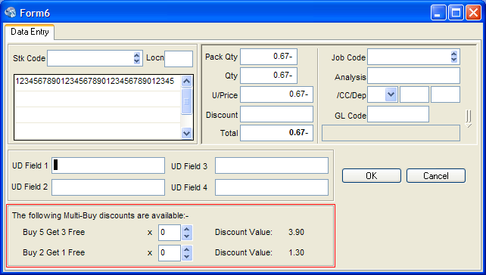

This section contains a scroll-box with a list of all available Multi-Buy Discounts for the specified Stock Code / Account in descending Buy Quantity order.

Each Multi-Buy Discount has a quantity field and a Discount Value field which is the MBD quantity multiplied by the lines Unit Price taking into account any line discount specified.

The MBD quantities will be automatically set (see 2.3) on change of Line quantity. The line validation will also be extended to ensure that the user cannot apply more multi-buy’s than are available for the specified line quantity.

The Discount Value will be recalculated on change of MBD Quantity, Line Quantity, Unit Price and Discount.

We can automatically manage the maximum MBD Quantity values that can be specified using the up/down controls associated with each MBD Quantity field whenever the line quantity changes or one of the MBD quantities is changed.

Where the Line quantity is insufficient for an MBD to be applied the fields will be disabled.

The Line Total field will be modified to take into account the MBD Discount Value’s.

If the Stock Code is changed, for example to an Alternate part, the MBD’s will be reloaded.

NOTE: If the user defined field section is hidden then the Multi-Buy section should be moved up to fill the gap, this will require that the OK/Cancel buttons are not moved centrally as they currently are.

* The Quantity/Price/Total block of fields is being moved into the Weirdo-Drop-Down-Thingie™ so that when it has dropped down the new discount fields can be seen (SPOP versions only).

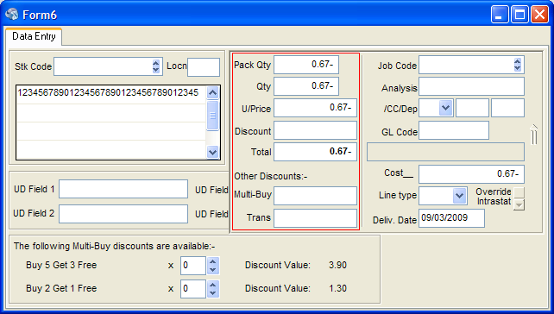

The Multi-Buy field will contain any additional line discount generated by Multi-Buy Discounts, this can be either a percentage or an amount discount depending on the definition of the Multi-Buy Discount.

The Trans field will contain any additional line discount generated by Transaction Total or Value Based Discounts at the transaction level being apportioned across the lines. This can be either a percentage or an amount discount depending on the definition of the Discount.

The existing Line Total field will be modified to take the Multi-Buy and Transaction Discounts into account.

When adding a transaction both fields will be read-only as they should not be set manually, when editing a transaction both fields will be read-write to allow incorrect discounts to be changed or removed.

When a Transaction Line is stored with one or more MBD’s having been applied to it we will add a Description Only line for each MBD applied where the description summarises the MBD, e.g. ‘Buy 3 WIDGET310 Get 1 Free’, etc.., and the quantity matches that on the original stock code line so that they can be picked proportionally when doing part deliveries.

### 2.2.7 Telesales Multi-Buy Discount Dialog

A Telesales transaction is generated by clicking the Finish button and selecting Generate Order, we will extend the Generate Order process so that before creating the order it checks the stock for Multi-Buy Discounts and builds up a list of available Multi-Buy Discounts which is presented in the following dialog:-

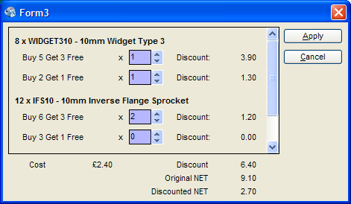

This is basically an extension of what we are doing on the Transaction Line (see 2.3.6) which supports multiple stock codes and presents transaction total information.

Fields in Scrollbox:-

Qty x Stock Code – the line quantity and stock code.

MBD Quantity – a edit/up-down control allows the user to change the number of each discount being applied.

Discount – this is the discount amount in transaction currency for the multi-buy line.

Fields at bottom:-

Cost – Total Cost Price for the transaction line – NOTE: Visibility of Cost/Margin information is controlled by User Permissions (Show_CMG in InvFSu3U.Pas) for Sales and doesn’t apply to Purchase and should be hidden.

Discount – This is the total discount for the lines.

Original NET – This is the line NET Total before MBD.

Discounted NET – This is the line NET Total after MBD.

Actions:-

Change MBD Quantity – When the MBD Quantities are changed the line Discount Value and Total Discounts will be recalculated. Validate will be provided to ensure that the number of MBD’s specified is valid.

Apply – Validates the MBD quantities and if OK creates the order with the appropriate discounts and description only lines.

*Note v2.3: The User Permissions for ‘Sales – Allow Sale below Cost’ And ‘Sales – Allow Discount to exceed Sale’ do not need to be checked as they work at the transaction level.*

Cancel – Exits the dialog and doesn’t apply MBD to the order.

**Warning - Tech Stuff** – It is expected that the list of discounts can be built up using frames, hopefully one parent frame per stock code and a series of individual discount frames within that. It is expected that a lot of the logic can be built into the frames and it is hoped that the individual discount frames can be used on the transaction line dialog as well. It is envisaged that an MBD class (or classes) can be developed to supply common services to the various areas in this spec that are affected by MBD’s.

### 2.2.8 Transaction Header Window

The Discount column on the Transaction Header window will be extended to show the two new Transaction Line Discount field, e.g. “3.00%/1.50/2.25%” where the section is the line discount, the second section is Discount2 (Multi-Buy) and the third section is Discount3 (TTD/VBD).

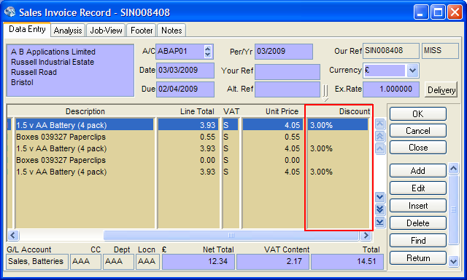

Where a discount isn’t set the section will be left blank, e.g. “/1.50/” if the Line Discount and Discount3 aren’t set. If non of the discounts are set then the column will be left blank.

## 2.3 Calculating

The Multi-Buy Discounts should be looked for in the following order until discounts are found:-

Customer/supplier + Stock Code + Transaction Currency

Customer/Supplier + Stock Code + Currency 0

Stock Code + Transaction Currency

Stock Code + Currency 0

As soon a discount has been found there is no need to search the next set.

The Multi-Buy Discounts should be applied in descending Buy Quantity order, e.g.

Line Qty = 29

Discounts – Buy 10 Get 7 Free, Buy 5 Get 3 Free, Buy 2 Get 1 Free

Check whether each discount should be applied starting with the highest buy quantity, then apply the remainder to the next discount and repeat until you run out of remainder or discounts:-

29 Div 17 = 1 remainder 12

12 Div 8 = 1 remainder 4

4 Div 3 = 1 remainder 1

This gives us the following Multi-Buy Discounts to be offered for the line:-

1 x Buy 10 Get 7 Free (Qty = 17)

1 x Buy 5 Get 3 Free (Qty = 8)

1 x Buy 2 Get 1 Free (Qty = 3)

Buy X Get Y Free discounts will credit back the line Unit Price less Line Discount excluding VAT for each free item.

Buy X Get Y% Off discounts will credit back Y% of (X * (Unit Price – Line Discount)).

Buy X For Amount discounts will credit back the difference between (X * (Unit Price – Line Discount)) and the specified Amount.

# 3.0 Total Transaction Discounts

The Total Transaction Discount (TTD) subsystem causes a discount dialog to be displayed when a transaction is stored so that the user can opt to apply a transaction wide discount which will be apportioned across the lines.

## 3.1 Trigger Conditions

TTD only applies to SPOP versions of Exchequer and only when the appropriate System Setup switch is enabled.

TTD only applies to xQU / xOR / xIN / xJI / SRI / PPI, their auto equivalents and Telesales.

### 3.1.1 Transactions

When adding supported transactions the TTD dialog will be displayed if the user has clicked the ‘Apply TTD’ button or menu option prior to storing the transaction. The code should execute before the ‘Before Transaction Save’ hook point is executed.

When editing an existing transaction the TTD dialog will be displayed if the user has clicked the ‘Apply TTD’ button or menu option prior to storing the transaction or if the transaction previously had a TTD and the Net Value of the transaction has changed. If a Value Based Discount (VBD) is present on the transaction then a warning should be displayed telling the user that applying a TTD discount will remove the VBD discount.

### 3.1.2 Telesales

The TTD Discount will be implemented within the Finish button – Generate Order process if the user has previously clicked the ‘Apply TTD’ button or menu option.

NOTE: This should execute after the Multi-Buy Discount code has added any applicable discounts and before the VBD section.

## 3.2 Total Transaction Discount Dialog

The following dialog is shown when storing a transaction under certain conditions (see 3.1):-

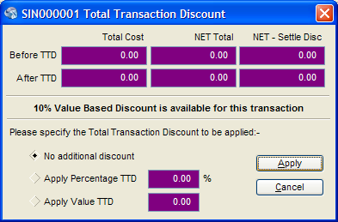

The section at the top is intended to keep the user informed as to what the situation is and illustrate how much discount they can give whilst still breaking even or making a profit. The After TTD row will be recalculated on the fly as the user changes the TTD settings at the bottom.

Please note that for purchase transactions the Total Cost and NET – Settle Disc columns will be greyed out as they are not relevant. (Greying out will look less weird than hiding the fields). Also the Total Cost column will be greyed out and if the user doesn’t have permission to view cost information (use Show_CMG in InvFSu3U.Pas)

*Note v2.3: A Discount Applied field has been applied at the bottom of the Net Total column which shows the value of the discount applied. Due to the fact the discount is specified at the unit level rounding errors often cause the discount applied to be slightly different from the discount requested. When they are different the Discount Applied field flashes.*

Below the transaction totals we have a Value Based Discount notification section, this will only be shown if there is a VBD that will be applied to this transaction if no TTD is given. If there is no VBD available then this section is hidden and the bottom section is moved up and the window height adjusted accordingly.

When editing an existing transactions the fields can be defaulted by analysing the existing transaction lines, if Discount3Type is set to 0 then default to ‘No additional discount’, if Discount3Type is set to 1 (TTD) then the *Discount3Type* and *Discount3* fields can be used to default it to the previously given TTD, if Discount3Type is set to 2 (VBD) then default to ‘No additional discount’ and popup a warning message that the transaction already has VBD.

*NOTE: This system of defaulting the dialog can result in incorrect defaults if a discount has been limited to avoid taking a line below cost.*

Fields:-

Before TTD – this section displays read-only information relating to the transaction without any TTD/VBD having been applied:-

Total Cost –the total cost of the transaction so that users can identify how much they can give away before making a loss.

NET Total – The NET Total of the transaction.

NET - Settle Disc – The NET Total of the transaction less the full settlement discount.

After TTD – this section displays read-only information relating to the transaction with the currently specified TTD having been applied but excluding any VBD:-

Total Cost – This will be the same as Before TTD – Total Cost as the cost is not affected by TTD for Sales and this column does not apply to Purchase transactions.

NET Total – The NET Total of the transaction after the current TTD settings have been applied.

NET - Settle Disc – For Sales this is the NET Total of the transaction after the current TTD settings have been applied less the full settlement discount. This column does not apply to Purchase transactions.

No Additional Discount – If selected then no TTD will be applied to the transaction, if editing an existing transaction then any prior TTD will be removed.

Apply Percentage TTD – default value 0 – This option causes a specified percentage TTD to be applied.

Apply Value TTD – default value 0 - This option causes a specified TTD amount to be applied (specified in transaction currency).

Actions:-

On change of TTD Percentage or Value – recalculate the After TTD figures. For both Percentage and Value TTDs the validation will check the following user permissions against the transaction totals after TTD and displays a popup error message:-



Apply button:–

No Additional Discount selected – for new transactions and existing transactions without TTD this closes the dialog and returns to the save transaction process without applying any TTD. For an existing transaction with TTD this option will remove it.

Apply Percentage TTD selected - Validate percentage as being >= 0% and <= 100%, if OK then apportion the discount across the lines removing any pre-existing TTD/VBD and return to the standard save transaction process.

Apply Value TTD selected – Validate amount >= 0 and <= Transaction Net Value, if OK then apportion the discount across the lines removing any pre-existing TTD/VBD and return to the standard save transaction process.

Cancel Button – closes the dialog and returns to the save transaction process without making any changes to the transaction. A new transaction will not have any TTD applied, an existing transaction without TTD will not have any TTD applied and an existing transaction with TTD/VBD will be left as is.

An additional description only transaction line should be added to notify the user/customer that a VBD was applied:-

Desc – ‘Transaction Total Discount of *percentage/amount* given’

## 3.3 Calculating

It is suggested that an object be written to manage the calculation of the discounts that can be used by the dialog and by the code to actually apply the discounts. Hopefully this can be re-used in other areas of the system such as well.

For percentage based discounts simply run through the transaction lines with values and apply the discount:-

Discount3 – Percentage Discount

Discount3Chr – ‘%’

DiscountType – 1 (TTD)

For amount based discounts run through the transaction lines to generate a list of values and then apportion the discount value across them with the remainder being allocated to the last line to ensure no rounding errors:-

Discount3 – apportioned value

Discount3Chr – #0

DiscountType – 1 (TTD)

Note (v2.3): As the TTD discount amount on the line is specified for a single stock item in pence there will often be rounding errors, e.g. Apply £5.00 TTD to a line for 6 items:-

£5.00 / 6 = £0.83333333333…

Round down (to avoid giving too much discount) to 2dp giving a TTD unit discount of £0.83

Total TTD Discount = £0.83 x 6 = £4.98

# 4.0 Value Based Discounts

Value Based Discounts allow the user to specify discounts to be applied automatically to transactions based on the value of the transaction before VAT and Settlement Discount.

Multiple breaks can be defined against individual Customers and Suppliers through the standard Discounts tab with a threshold amount and either a percentage or value based discount. The VBD with the highest available threshold will be applied to the transaction.

Value Based Discounts will not be applied if a transaction already has a Total Transaction Discount applied to it.

## 4.1 Trigger Conditions

VBD only applies to SPOP versions of Exchequer, there is no System Setup switch to enable it as the definition of VBD’s against Customer/Supplier Accounts causes it to be implemented.

VBD only applies to xQU / xOR / xIN / xJI / SRI / PPI, their auto equivalents and Telesales.

### 4.1.1 Transactions

When adding supported transactions the VBD will be automatically applied when saving the transaction if no TTD discount has been previously applied.

~~When editing an existing transaction the VBD cannot be automatically updated as the VBD’s which applied to the original transaction may have been deleted or modified so the user will be warned to update them manually.~~

v2.4: When editing an existing transaction the VBD system will detect changes in transaction Net Total, account code, transaction date and currency:-

* If the transaction does not have VBD and it now qualifies then it will be applied automatically.
* If the transaction does have VBD then the user will be asked if they want to update it, if they say Yes then the VBD will be recalculated which can result in increased or decreased discounts. NOTE: It is assumed that the users will leave VBD’s with effective dates in place for a reasonable period after the have expired.

### 4.1.2 Telesales

The VBD will be implemented within the Finish button – Generate Order process and will be automatically applied if no TTD is present.

NOTE: This should execute after the MBD and TTD code has executed.

## 4.2 Implementation

### 4.2.1 Customer/Supplier Discount Tab

Value Based Discounts will be added via the standard Discounts Tab on the Customer/Supplier Record (fake screenshot):-

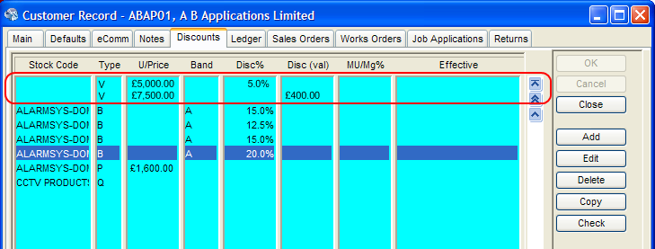

As no Stock Code is specified Value Based Discounts should appear at the top with a ‘V’ type against them, the starting value of the range is shown in the Unit Price column and the Discount to be given in either the Disc% or Disc (val) columns depending on how the discount is defined.

Please note that the order that the VBD rows is shown in cannot be controlled due to technical limitations.

The Block Delete Discounts process accessible via the Delete button will need to be updated to handle VBD records.

### 4.2.2 Discount Detail Window

The Discount Detail window will need to be extended to support Value Based Discounts, unfortunately due to the first field being the Stock Code it is recommended that this dialog be changed so that the Discount Type field is first as Value Based Discounts have no Stock Code and requiring the user to enter one is likely to cause support and training issues.

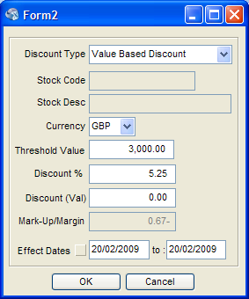

For Value Based Discounts the following fields are required:-

Discount Type – Value Based Discount

Currency – the currency of the threshold amount where this VBD takes effect

Threshold Value – the threshold amount where this VBD takes effect

Discount% - the Discount percentage to be applied

Discount (Val) – the Discount Value to be applied

Effect Date – Effective Date Range

For Value Based Discounts the following fields are not required and should be shown visibly as not required:-

Stock Code

Stock Description

Band

Mark-Up/Margin

NOTE 1: Care should be taken as this form (StkQtyU.Pas) is also (ab)used for Quantity Break entry as well.

NOTE 2: Also fix the font on ‘Effect Dates’ while we have the hood up.

## 4.3 Calculating

The VBD Discount can be apportioned across the transaction lines in the same manner as the TTD Discount.

See section 3.3 for further details.

VBD Discount should ignore the following user permissions as it has been decided that if the discounts have been set up then they should be applied.



*Note: This will probably require a mod to the validation code for the affected transactions to allow edits to transactions with VBD that break the above rules.*

An additional description only transaction line should be added to notify the user/customer that a VBD was applied:-

Desc – ‘Value Based Discount of *percentage/amount* given’

## 4.4 Value Based Discount Records

Due to the requirement to integrate Value Based Discount Range records into the existing Discount tabs in Exchequer the records will have to be stored in the pre-existing Customer/Supplier/Stock Discount record (CustDiscType ) in ExStkChk.Dat.

The fields on the CustDiscType will be set as follows for VBD records:-

DiscCode : String[26]: Index 0 – Account (6) + Space (16) + QBCurr

QStkCode : String[20]: Index 1 – Stock Code – blank for Cust/Supp

Spare3K : String[10]: Index 2 – Spare – Not Set

DCCode : String[10]: Customer/Supplier Code – blank for Stock

QBType : Char: Discount Type - ‘V’ – Value Based Discount

QBCurr : Byte: Currency – Multi-Currency Editions Only

QSPrice : Double: Threshold amount

QBand : Char: - not set

QDiscP : Double: % VBD to be applied

QDiscA : Double: Value VBD to be applied

QMUMG : Double: - not set

CUseDates : Boolean: Use Effective Dates

CStartD : LongDate: Effective Start Date

CEndD : LongDate: Effective Finish Date (>= Effective Start Date)

NOTE: Precautionary checks should be done on the rest of Exchequer to ensure that it won’t use the new VBD Discount Records in existing code accidentally.

# 5.0 Database Changes

## 5.1 Transaction Lines (Trans\Details.Dat)

The following new fields will be added to the Transaction Line:-

Discount2 : Double; // Multi-Buy Discount

DiscountChr2 : Char; // #0=Amount, %=Percentage

Discount3 : Double; // Transaction Based Discount (TTD/VBD)

DiscountChr3 : Char; // #0=Amount, %=Percentage

Discount3Type : Byte; // 0=Undefined, 1=TTD, 2=VBD

### 5.1.1 Applying Fields

In order for Exchequer to add up we will need to integrate these fields throughout Exchequer, the current plan is to identify where the existing Line Discount fields, Discount and DiscountChr, are in use and to analyse and extend those areas as necessary.

A case-insensitive search of the v6.01 code for ‘discount’ has found approximately 3200 references which will need to be checked manually.

If we assume that 20% can be eliminated immediately from the search results, 30% of them only require a quick look (1min), 40% require some changes (5min) and the remaining 10% require more serious work (30min) then that gives us 16960 minutes or 283 hours or 38 working days.

## 5.2 System Setup (ExchqSS.Dat)

The following new fields will be added into System Setup:-

Enable Total Transaction Discounts (default=off)

## 5.3 Multi-Buy Discounts File (Misc\MultiBuy.Dat)

This new file will be used to store the Multi-Buy Discount Records for Customers, Suppliers and Stock.

TMultiBuyDiscountType = (mbtGetFree, // Buy X Get Y Free

mbtForAmount, // Buy X For Amount Y

mbtGetPercentOff) // Buy X Get Y% Off

MultiBuyDiscountRecType = Record

mbdType : Char; // ‘C’=Customers, ‘S’=Suppliers, ‘Q’=Stock

mbdAccountCode : String[30]; // Account Code – pad with blanks – blank for stock

mbdStockCode : String[30]; // Stock Code – pad with blanks

mbdCurrency : Byte; // Currency for amount based discounts else 0

mbdMultiBuyType : TMultiBuyDiscountType;

mbdBuyQuantity : Double; // X - Buy Quantity for all types

mbdRewardValue : Double; // Y - Discount type dependant

mbdUseDateRange : Boolean;

mbdStartDate : LongDate;

mbdEntDate : LongDate;

// + loadsa spare

End; // MultiBuyDiscountRecType

Index 0: mbdType +

mbdAccountCode +

mbdStockCode +

mbdCurrency +

mbdMultiBuyType +

mbdBuyQuantity

Other indexes to be added as required during development.

# 6.0 Other Exchequer Core Work

## 6.1 Back-To-Back Orders

The Back-To-Back Order process will need modifying to automatically remove the TTD/VBD/MBD discounts and information lines from the Sales Order when creating the Purchase Order and to offer/apply any discounts valid for the Purchase Order.

For Multi-Buy discounts it should work like Telesales with a single dialog offering all available discounts applicable, see 2.3.7.

VBD will be automatically applied if applicable.

If the user wants to apply TTD then they can click the ‘Apply TTD’ button or menu option in the POR window which is opened automatically and then store the transaction.

## 6.2 Customisation

The Customisation should be extended to support the new Transaction Line and System Setup fields. The new discount fields are reserved for TTD/VBD/MBD and will not be made read-write through the customisation at this time.

A new entCalc_PcntPcntAD function will need to be added to support the Tax Settlement Discount plug-in.

## 6.3 SQL Edition

The System Setup and Transaction Line schemas will need updating.

A new schema will need to be generated for Misc\MultiBuy.Dat.

A conversion process will need to be written to generate new fields/tables in existing systems.

The Blank and Demo data import files will need updating.

## 6.4 Installer

The Install and Add Company processes will need to be modified to install Misc\MultiBuy.Dat.

The Upgrade process will need to be modified to replicate Misc\\MultiBuy.Dat out to all companies, being careful not to overwrite existing files.

## 6.5 Letters

A new field ENTPRS.LINE.MULTIDISC will be added which shows all three discounts as per what we are doing for the lines list on the transaction header dialog, e.g. ‘5.00%/£1.50/10.25%’, ‘’5.00%//10.25%’, etc…

# 7.0 Other Exchequer Modules

## 7.1 Toolkit DLL

The Toolkit DLL should be extended to support the new Transaction Line and System Setup fields.

In order to provide support to the Trade Counter and bespoke/3rd party the following Toolkit DLL functions should be upgraded to support Value Based Discount records:-

Ex_GetDiscMatrix

Ex_StoreDiscMatrix

Ex_DeleteDiscMatrix

Additionally new functions should be added to support Multi-Buy Discount records:-

Ex_GetMultiBuys

Ex_StoreMultiBuys

Ex_DeleteMultiBuys

## 7.2 COM Toolkit

The COM Toolkits should be extended to support the new Transaction Line and System Setup fields.

The Customer/Supplier Discounts Object (IAccountDiscount) should be extended to Value Based Discount records.

A new acMultiBuys/stMultiBuys sub-object should be added off the Customer/Supplier and Stock objects to provide access to and maintenance of any Multi-Buy discounts defined against the Customer/Supplier/Stock.

On the Transaction Line a new tlMultiBuys sub-object will be added, it will be loaded automatically by ImportDefaults with the Multi-Buy Discounts applicable to the current Stock Code. Against each discount will be an ApplyQty which will be automatically set whenever the line quantity is changed. If the application doesn’t want to apply the discounts then the ApplyQty can be set to zero. The Multi-Buy Discounts will be applied to the transaction by ITransactionLine.Save, validation will ensure that the number of discounts to be applied is correct.

On the Transaction object a new ApplyTTD method will be added so that applications can easily apply a Transaction Total Discount:-

TTTDType = enumeration (ttdPerc, ttdValue)

Function ApplyTTD (Const TTDType : TTTDType; Const Value : Double) : LongInt

The Transaction.Save method will be extended to automatically apply Value Based Discounts if no Transaction Total Discount is present.

## 7.3 Form Designer

New data dictionary fields will be added for the new Transaction Line fields.

Example forms showing how to suppress TTD/VBD/MBD lines and show discount totals will need to be developed (PM/QA?).

## 7.4 eBusiness

When transactions are imported into the eBusiness Daybook automatically by the eBusiness Importer the ‘Re-Apply Exchequer Pricing’ flag in the eBusiness System Setup will be checked and if set it will automatically apply Multi-Buy Discounts to the lines and Value Based Discounts to the Transaction.

NOTE: TTD Discounts cannot be supported during the import as they require a user interface.

The eBusiness Daybook’s Transaction Header window will be extended in the same way as the standard Exchequer Transaction Header window to support TTD (see 3.1.1/3.2).

The COM Pricing object will be extended to provide access to lists of Value Based Discounts and Multi-Buy Discounts.

## 7.5 Importer

Should be extended to support the new Transaction Line fields (requires 7.1/7.2 Toolkits) and Multi-Buy Discount Records.

## 7.6 ODBC DDF’s

Should be extended to support the new Transaction Line fields and Multi-Buy Discounts table.

Note: The System Setup table is not supported by the DDF’s.

## 7.7 Trade Counter

Trade Counter should be modified to support Transaction Total, Value Based and Multi-Buy Discounts (requires 7.1/7.2 Toolkits).

## 7.8 Plug-Ins

Any Plug-Ins calculating transaction or line totals will need reviewing and possibly changing, such as the Tax Settlement Discount Plug-In which will need the VAT Calculation modifying to include the new discount fields.

## 7.9 OLE Drill-Down

### 7.9.1 Transaction Header Dialog (TranSOPF.Pas)

Modify discount column as per Exchequer transaction header.

### 7.9.2 Transaction Line Dialog (SOPLineF.Pas)

Modify Transaction Line dialog as per Exchequer transaction line dialog.